

OOO NPP BIOMER

MILK ANALYZER

KLEVER-2M

Operation manual

OP 2007.24.02\2.

Listed in the State Register of Russian Federation for measuring instrumentation
and approved for application by the Federal
Agency for Technical Regulation and
Metrology of the Russian Federation



Novosibirsk
2008

CONTENTS

1. GENERAL GUIDELINES 4
2. DESCRIPTION AND OPERATION 4
2.1 Analyzer Function 4
2.2 Specifications 6
2.3 Completeness 7
2.4 Marking and Sealing 7
3. OPERATING THE ANALYZER 8
3.1 Safety Requirements 8
3.2 Setup Procedures 8
3.3 Selection and Preparation of Samples 10
3.4 General Instructions 11
3.5 Measurements in Mode 1 14
3.6 Measurements in Mode 2 15
3.7 Extra Modes 17
3.7.1 ROM Write Mode 17
3.7.2 Correction of Mode 1 17
3.7.3 Resetting Corrections 17
3.7.4 Zero Adjustment of the Device 18
3.8 Setting Up the Analyzer 19
3.8.1 Analyzer Menu 19
3.8.2 Description of Menu Actions 21
3.8.3 Setting Up External Devices 22
3.8.4 Software Setup 23
4. MAINTENANCE 24
4.1 General Instructions 24
4.1.1 Preparation of the Washing Solution 24
4.2 Daily Washing of the Analyzer 24
4.3 Monthly Washing the Analyzer 25
4.4 Operability Check of the Analyzer 26
4.5 Troubleshooting 27
5. STORAGE 29
6. TRANSPORTATION 29
7. RECYCLING 30
8. ADDENDA 30
8.1 Control options for Mode 2 30
8.2 Use of Сorrection of Mode 1 31
8.3 Determination of Added Water in Milk 32
8.4 Purpose of Calibrations and Modes of the Analyzer 33
8.5 Milk Homogenization Rate 34
8.6 Milk Freezing Point 34
8.7 Measuring Cream of Fat Content Over 20% 35
8.8 Certified Mixtures for Verifications 36
8.9 Possible Discrepancies in the Readings 37
8.9.1 Discrepancies Related to the Analyzer Faults 37
8.9.2 Discrepancies Related to Errors of the Controlling Methodology 38
8.9.3 Discrepancies Related to the Specifics of a Region and Feeding of the Milk Herd 38

1. GENERAL GUIDELINES

The Klever-2M milk analyzer designed for measuring the typical quantity of cow milk (hereinafter, milk measurements). Laboratory assistants (operators) of higher and intermediate qualification trained to observe safety regulations are admitted to conduct measurements. The operators must become familiar with the operation manual of the milk analyzer and the methodology for measurements attached to the device.

The analyzer is manufactured as a portable device that is guarded from external influences and can operate in plant, laboratory and field conditions.

The analyzer operates in a standalone mode, but it can be connected to a computer for calibration or logging measurement results, for which there is respective software.

The analyzer also supports wired and wireless output of resultant data to a thermoprinter, or to an external indication.

In the base supply option, the analyzer is shipped with two calibrations: factory calibration for milk and its reprocessed products, and custom calibration to analyze a specific product. For details, see Section 8.4).

2. DESCRIPTION AND OPERATION

2.1 Analyzer Function
The Klever-2M milk analyzer (hereafter—analyzer) is designed for measuring the milk freezing point, mass contents of fat, protein, lactose, mineral salts (ash) and density in milk and diary products as per the duly certified measuring methodology. Additionally, the analyzer determines the mass content of the milk solids, nonfat milk solids content and milk homogenization rate, as well as indicates the temperature of the sample with the calculated quantity of added water.
The operation principle of the analyzer is based on the fact that ultrasonic oscillations are passed through the sample, and the output signal values are registered versus the values of measured parameters of a milk product or its whey. The analyzer is a portable desktop device comprising a container for heating the sample, a source of ultrasonic oscillations, a receiver, an amplifier, a microprocessor-controlled data processing and logging unit, and an LCD indicator. There is an output to plug into a computer. The analyzer is microprocessor-controlled. The analyzer is calibrated with samples whose composition is defined based on standard measuring techniques. The parameters of calibration characteristics are stored in the memory of the analyzer.

Measurement results are displayed in digital form with increment 0.01 %.

This analyzer offers two measurement modes. In Mode 1, the subject itself (milk or milk product) is required. By technical and metrological specifications, Mode 1 of the analyzer is similar to the Klever-2 model of a milk analyzer being produced. Mode 2 implies a sequential measurement of an object and its whey, thus providing increased precision and stability of the readings.

For field operation, a power source with additional voltage stabilizer is required for plugging into the car electrical system. It can be purchased at the manufacturing plant.

Operating Conditions of the Analyzer
Ambient air temperature ….… from +10°С to +35°С.
Relative air humidity………… up to 80% at 35°С.
Atmospheric pressure ……..… from 84 to 106 kPa.
Sample temperature………..… from +5°С to +35°С.
Power supply voltage:
- in 50 Hz AC mains……. from 187V to 242V.
- DC power supply source ..…. from 10V to 15V.
The analyzer must be protected against the exposure of strong vibration sources, magnetic and electrical fields.

2.2 Specifications
Table 1
Parameter Name | Value
Tested sample volume, ml | 20
Sample volume in Mode 2, ml | 200
Measuring time, max, min. | 3.5
Measuring time in Mode 2, max, min. | 8
Continuous operating time, h | 12
Max. power consumption, not more than, W | 25
Overall dimensions of the device for transport, mm | 257х132х108
Height of the analyzer in position, mm | 297
Total average service life of the analyzer, years | 5
Weight of the analyzer, not more than, kg | 1.0

Ranges and Tolerable Inaccuracies of Measurement
Ranges and Limits of Measurement Inaccuracies (∆, at Р=0.95) for Mode 1 and 2 are Shown as per Measurement Technique 2009.13.03/2.

Table 2
Indicator | Mode 1 |  | Mode 2
Indicator | Range | ∆ | Range | ∆
Fat | 0-6.0% | ±0.06% | 1.5-5.5% | ±0.06%
 | 6.0-10.0% | ±0.1% | No | -
 | 10.0-20.0% | ±0.2% | No | -
NMS | 3.0-15.0% | ±0.15% | 6.0-15.0% | ±0.15%
Protein | 0.15-6.0% | ±0.15% | 2.0-5.0% | ±0.06%
Lactose | calculated |  | 3.5-5.0% | ±0.06%
Mineral salts | calculated | * | 0.5-1.5% | ±0.02%
Density | 1,000-1,050 kg/m³ | 0.3 kg/m³ | 1,000-1,050 kg/m³ | 0.3 kg/m³
Homogenization | 0-100% | * | 0-100% | *
MS | calculated | * | calculated | *
Freezing point | –1.0 - –0.1^{о}С | * | –0.8 - –0.4^{о}С | ±0.008 ^{о}С
Added water | 3-70% | * | 3-70% | *
Temperature | 5-35^{о}С | * | 5-35^{о}С | *
The metrological specifications of the output signal of the analyzer are indicated in the passport (PT 2007.07.02\2).

The metrological specifications of the analyzer are not guaranteed for measurements of counterfeit (by whatever means) milk and milk product in which artificial additives were introduced.

2.3 Completeness

The delivery set of the Klever-2M milk analyzer includes:

Table 3
 | Product Name | Q-ty
1 | Measurement unit | 1 pc.
2 | Power source RPN-12-1.5 | 1 pc.
3 | Power cord | 1 pc.
4 | Set of spare parts, tools and accessories | 1 pc.
5 | Checking kit | 1 pc.
6 | Passport | 1 pc.
7 | Operation manual | 1 pc.
8 | Verification procedure | 1 pc.
9 | Measurement technique | 1 pc.
10 | Instructions for preparing certified mixtures | 1 pc.
11 | Washing set | 1 pc.
12 | Kit of chemicals for double measurements | 1 pc.

2.4 Marking and Sealing

The following marking is made on the analyzer’s housing:
- badge of the State Register of Measuring Instruments (Gosreestr SI);
- trademark of OOO NPP BIOMER;
- serial number of the analyzer as per the numeration system adopted at OOO NPP BIOMER; and
- identification number of the analyzer: Klever-2M Milk Analyzer; TU 4215-007-45455637-06.

The marking is made on the front panel, on the bottom part of the analyzer measuring unit, and on the cover page of the passport.

The sealing plugs are on the rear panel of the analyzer housing.

3. OPERATING THE ANALYZER

3.1 Safety Requirements

Place the analyzer on a dry smooth surface cleared of any objects. Prior to powering on the analyzer to the mains, make sure the insulation of the power cord, the housing and the power source are not damaged.

The analyzer is to be powered on to the 220V mains only in its operative position and only to the grounded mains socket.

Always disconnect the analyzer mains plug:
- on moving it to a new place or during transportation;
- on wet cleaning the surface on which the analyzer is installed;
- on wiping the analyzer surface with wet cloth; and
- on operation timeouts over 24 hours.

Do not operate the analyzer:
- if the ambient air temperature is outside the range from +6°С to +35°С;
- if the relative air humidity is close to 100% (when the ceiling, walls, floor and objects within the premises are covered with moisture);
- in premises with corrosive environment.

Never uncover the housing of the analyzer and the power source. Only personnel trained to observe the safety regulations and familiar with this manual can be admitted to operate the analyzer.

3.2 Setup Procedures

Bring the analyzer into the operating position (Fig.1 Device Assembling- disjoint it into two parts;
- place the power source where the guide contacts are located on a horizontal surface;
- slide the guides into the notches on the side of the measuring unit and, keeping the measuring unit in horizontal position, move it along the guides against stop;
- plug the power cord to the analyzer power source;

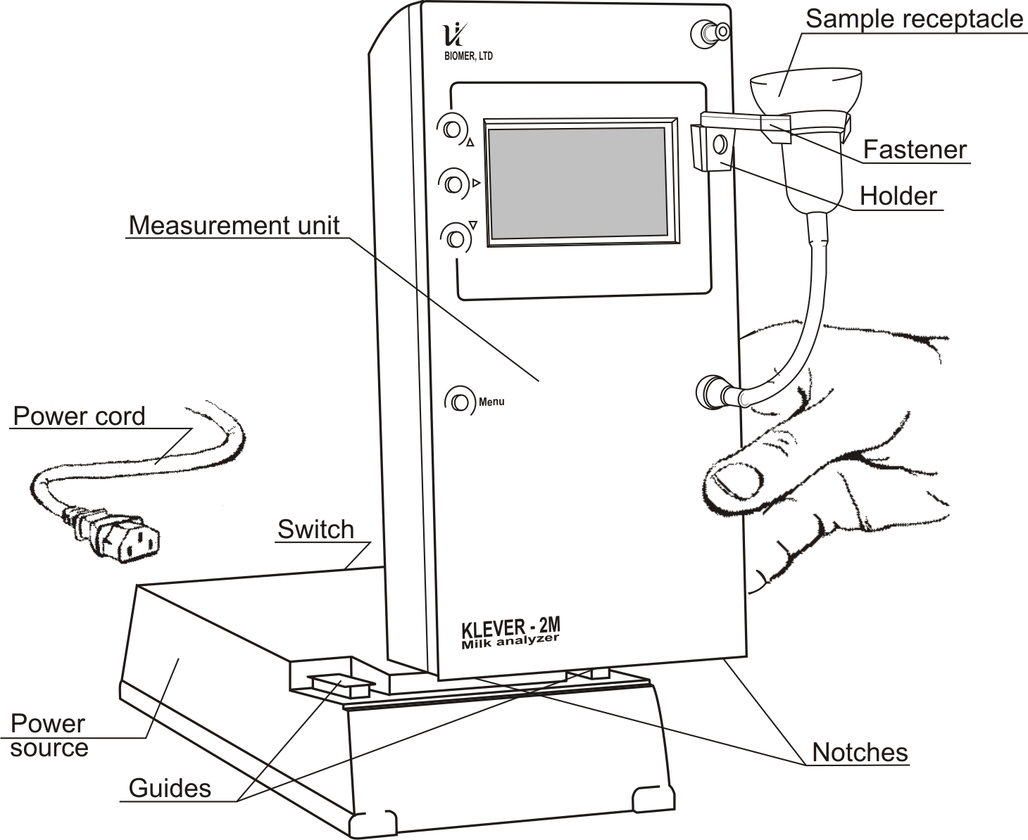

Fig.1 Device Assembling
- insert the mains plug of the power source to the 220V (50Hz) mains socket and turn the analyzer on with the switch.

The design of the analyzer provides its operation from the car battery.
To this end, use a power source equipped with a voltage stabilizer SN-12-1.5 which is shipped with the analyzer at the customer’s request at extra charge.

3.3 Selection and Preparation of Samples

The selection and preparation of samples are to be conducted following the rules of selection and preparation as described in detail in GOST 26809-86 and GOST 13928-84. To produce correct indications of the analyzer, remember that:
- Sample must be homogenous.

If there is a layer of settled fat (cream), the milk sample should be heated in a water bath up to +40-+45°С, then mixed, cooled to (+25±2)°С and then stirred again. This is the temperature that provides the highest measurement accuracy. Stir the mix through pouring it from one container to another at least three times.
- Milk acidity should not be over 25°Т.
- Parameters of the sample (temperature and composition) should be within the tolerable ranges (see Table
- Metrological specifications may vary on analyzing ice-cream, whey, reconstituted and canned milk (see also Section 8.4).
- For homogenized cream, depending on the homogenization rate (efficiency), the upper measurement range of the mass contents of fat may go down to 8-12%.
- Sample must be degasified.

Fresh milk, skim milk, and cream after separation contain a substantial amount of air which introduces errors to the measuring results produced by the analyzer.

To withdraw the air, degasify the sample: heat it up to +45-+50°С, keep it at this temperature for 5 minutes, stir and cool it to (+25±2)°С.
The manufacturing plant has developed a syringe-degasifier. Air is withdrawn during 1 minute without heating the sample. The syringe-degasifier is shipped on the customer’s request.
- Sample must not contain artificial additives.

In case the milk needs to be canned (for no more than 3 days), consider the possible effect of the preservative upon the analyzer readings.

3.4 General Instructions

Once powered on, the analyzer warms up in about 20 sec.

If during analyzer warm up there are water or sample residues in the sample receptacle, drain the sample to switch to the ready mode (Fig. 2 Draining the Sample
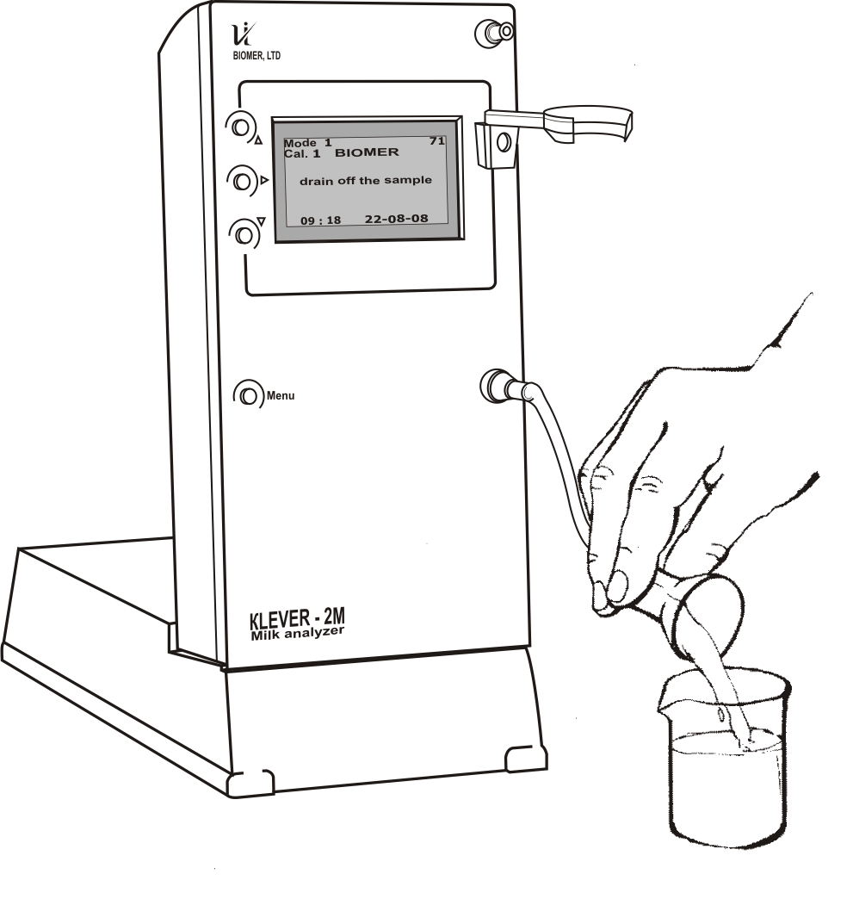
Fig. 2 Draining the Sample

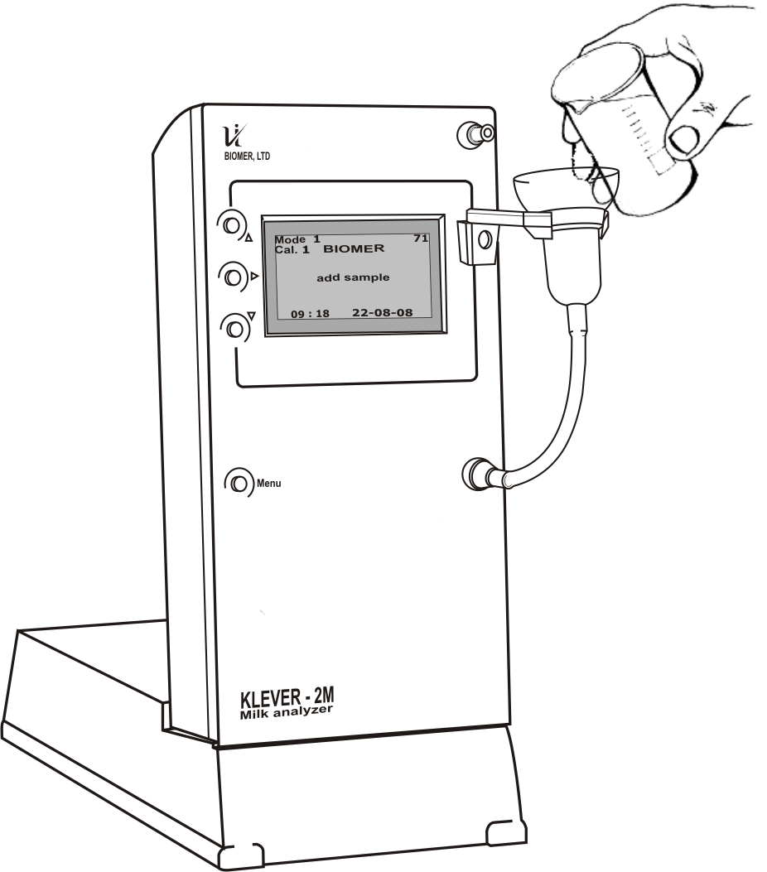

Fig. 3 Pouring the Sample for Measurement

Then the analyzer loads the last saved settings automatically and switches to the ready mode. The “add sample” indication appears on the display (Fig. 3 Pouring the Sample for Measurement

At this time (Fig. 5, Fig. 7), the measurement mode, calibration, settings and the parameters of the analyzer can be changed if necessary. By default, the manufacturing plant has set the optimum configuration of settings. Prior to changing them, it is recommended to review Section 3.8.2 of this Manual, as well as Section 8 that provides explanations related to application of modes and settings of the analyzer.

The sample should be poured into the sample receptacle up to a level of 5-7 mm below its upper edge (Fig. 4).

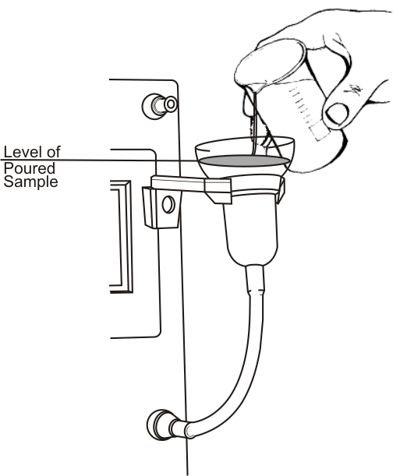
Once the sample is poured into the analyzer, a schematic “timeline” appears on the display that indicates the measuring time. This operation is indicated by the analyzer as “preparing”. At this moment, in case of erroneous sample choice or if a pre-washing of the measuring cell is needed, the sample can be drained (Fig.2) and then poured again on switching to the ready mode.
To produce a more accurate result, do not stir or add the sample during measurements, or subject the analyzer to a mechanical action.
Fig. 4 Level of Poured Sample

In case the text "Internal error drain off the sample" is indicated, drain the sample and pour it again into the sample receptacle once the ready mode is activated (see Table 4).

While measuring a sample of milk whose fat content differs by more than 3% from the previous, it is strongly recommended to wash the measuring cell of the analyzer with milk of a new sample, that is, drain the sample while preparing the measurement.

On timeouts between measurements up to 2 hours, it is recommended to wash the measuring cell with distilled or pure boiled water having the temperature +15-+30°С, then pour the water and perform one measurement. Leave the analyzer in this condition until the next measurement.
On operation timeouts longer than 2 hours, or prior two shutting down the analyzer at the end of the working day, wash the measuring cell with a washing solution as per the guidelines of Section 4 of this Manual.

3.5 Measurements in Mode 1

Prior to execution of measurements, closely review the Measurement Technique (MT) supplied with the analyzer documentation kit. If necessary, perform a measurement accuracy indication check prior to measurements and compile analysis protocols as per sections 10 and 11 of the mentioned Technique (MT).

Then it is recommended to run a functional test and customize settings of the analyzer depending on the object being measured and the required form for obtaining results. To this end, choose the required calibration and the indicated readings needed to the user. If the analyzer needs to be connected to a computer, thermo printer, or an exterior gauge, the respective software has to be installed and preliminarily set up. On activation of the ready mode, the display looks like this (Fig. 5):

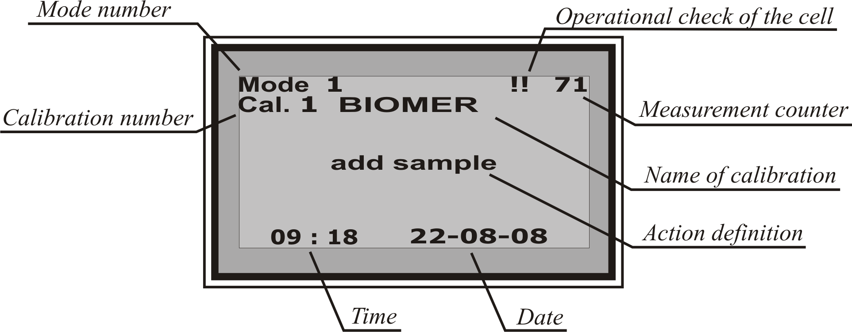
Fig. 5
Depending on the object measurement may take about 2-3 minutes. Once the measurements are complete, the display indicates the values of measured readings which can be viewed by pressing the «▼», «▲» buttons (Fig. 6).

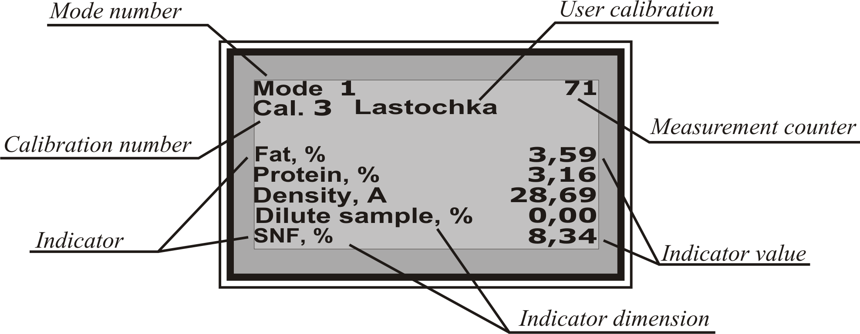
Fig. 6

3.6 Measurements in Mode 2

The Klever-2M analyzer offers a mode that allows conducting a simultaneous measurement of full raw milk and whey prepared from this milk. This mode is specific in a longer time it takes to produce the result, but allows measuring four indicators of milk composition simultaneously (fat, protein, lactose, and mineral salts) and offers a much higher precision of the analysis. For comparison of the metrological specifications for the modes 1 and 2, see Table 2 of this Manual. Mode 2 also allows for correct measurement of milk content per each animal, of milk with artificially modified composition, and of milk that underwent mechanical or thermal treatment.

To operate the analyzer in Mode 2 of measurement, closely review the respective section of the Measurement Technique. This mode is also used to correct Mode 1, therefore it is recommended to carefully follow the sequence of operations mentioned in the Measurement Technique and use only the equipment and chemicals recommended by the technique.

On noncompliance with the rules and recommendations disclosed in the technique, as well as on using chemicals and equipment of a brand other than recommended, which do not provide the relevant conditions for measurements, the accuracy may be degraded substantially.

In Mode 2, it is recommended to keep track of the “action definition” indication on the display of the analyzer (Fig. 7) and keep to the sequence of actions prompted by the analyzer. It is also strongly recommended to wash with the sample (of whey and milk) prior to measurements, or enable the stability control option.

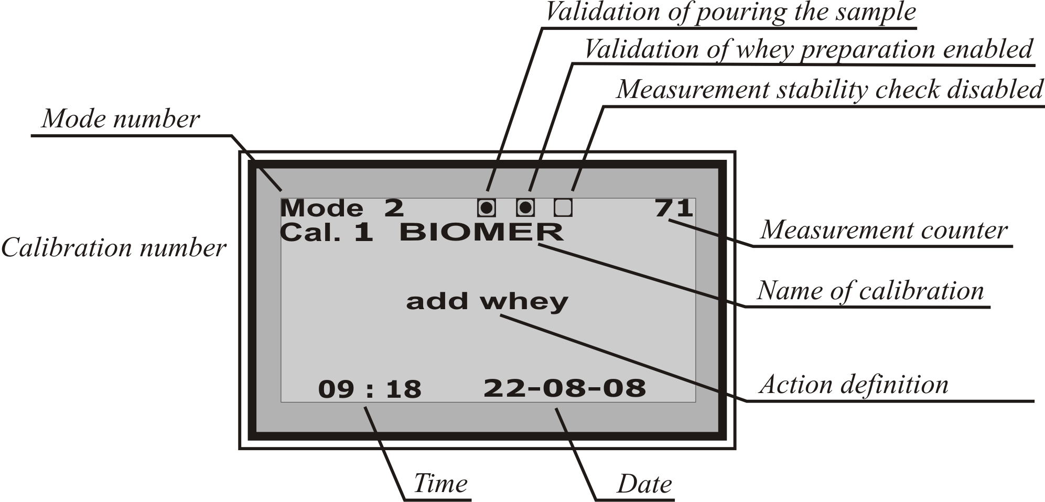
Fig. 7
The operation sequence and display of results in Mode 2 is similar to that described above (Fig. 8). In Mode 2, some of the readings are not displayed by default.

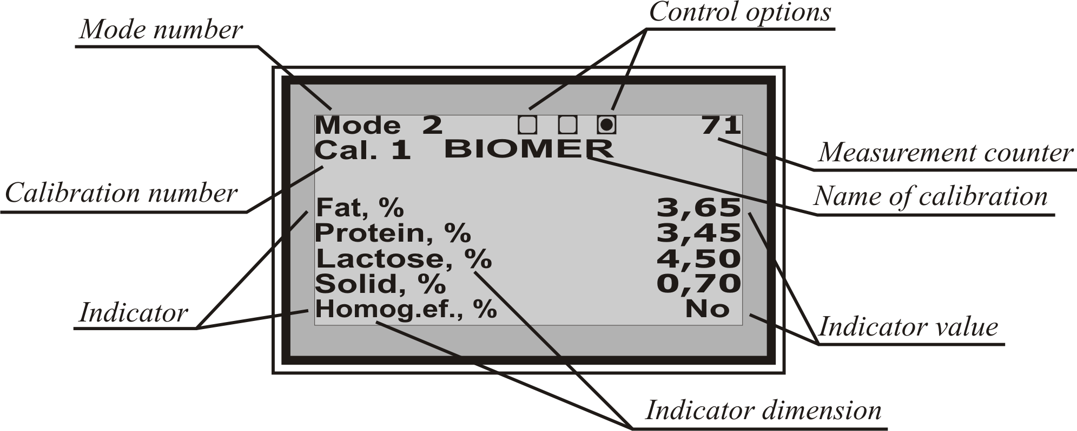
Fig. 8

3.7 Extra Modes

3.7.1 ROM Write Mode
This mode is used to write calibrations or any other internal settings of the analyzer. To enter this mode, power on the analyzer with the “▲” button pressed. In so doing, the digits of the serial number are displayed together with the info of the current modification and the indication of the write mode.

3.7.2 Correction of Mode 1
Correction modifies the calibration characteristics of Mode 1 based on the results produced while running measurements in Mode 2. Correction of Mode 1 is performed independently for each calibration of the analyzer.

For details, see Section 8.2 of this Manual.

3.7.3 Resetting Corrections
Resetting corrections undoes the results of correction of Mode 1 and restores the analyzer to the factory-default calibration characteristics. At the same time, the threshold value of NMS and the average freezing point are returned to the factory-default settings. Resetting corrections is performed independently for each calibration of the analyzer.

3.7.4 Zero Adjustment of the Device
The inner parameters of the analyzer cell may change with time. The zero adjustment takes account of the changes that have occurred and corrects the calibration characteristics thus retaining their stability and correctness.

«Resetting correction» (see Section 3.7.3) does not undo the results of zero adjustment. If you think that the zero adjustment was performed incorrectly, repeat it observing the following conditions:

The need for zero adjustment should be ascertained only after the analyzer’s maintenance and if deviations in readings found with distilled water exceed the deviations specified in Section 4.4.

Zero adjustment must be effected only using distilled water.

Prior to the works, perform three measurements using distilled water in the regular mode. Then switch the analyzer to the zero adjustment mode. To this end, select the respective option in the “Service” menu and confirm selection by pressing the “►” button. The analyzer will switch to the zero adjustment mode automatically. After that, pour distilled water of the temperature (+25±2)°С following the “action definition” text indicated on the display.

On completion of the adjustment, the analyzer displays a respective text message, corrects the zero position and writes adjustment data into the inner memory. After that, the analyzer automatically switches to the ready mode for measurements.

If zero adjustment is impossible, a respective text message is displayed. In so doing, no zero adjustment is performed. It should be repeated.

Once the zero adjustment has been performed correctly, further results of measurements using distilled water should be within the limits specified in Section 4.4. Do not run any measurements within 15-30 minutes after the zero adjustment is over.

3.8 Setting Up the Analyzer

3.8.1 Analyzer Menu
The analyzer menu is invoked by pressing the “menu” button and looks like this.

1|------Save
2|------Print
3|------Calib. selection
|------Calib. 1 BIOMER
|------Calib. 2 User
|------ …….
4|------Mode Selection
4.1|------ Mode 1
4.2|------ Mode 2
5|------Service
5.1|------ Do zero correction
5.2|------ Mode 1 correction
5.3|------ Undo correction
6|------ Setup
6.1|------ Time
6.2|------ Date
6.3|------ User F.point
6.4|------ SNF level
6.5|------ Mode 1
6.5.1|------ REPEAT Service
6.5.2|------ PRINT Service
6.5.3|------ Content index
|------ Fat
|------ Protein
|------ ……...More
6.6|------ Mode 2
6.6.1|------ REPEAT Service
6.6.2|------ PRINT Service
6.6.3|------ Sample control
6.6.4|------ Whey control
6.6.5|------ Precision control
6.6.6|------ Content index
|------ Fat
|------ Protein
|------ ……...More
6.7|------ Contrast
6.8|------ Bright

There are 4 buttons to navigate around the options and select the required action: “Menu”, “►”, “▼”, and “▲”. In the left-hand part of the display, there is a “cursor” controlled by the “▼” and “▲” buttons. On selecting the required option, press the “►” button to enable the option. Pressing the “Menu” button in any section will move you one section upwards over the menu structure up to the ready mode.

If an option of the analyzer settings can be enabled/disabled, then if it is enabled, there is a checkmark “√” near it. To disable an option, move the cursor over it and press the “►” button, the “√” checkmark will go off. Any required option is enabled in a similar way. At the same time, change of the status can be also indicated on the main display of the analyzer in the ready mode.

On setting up the numerical data of the analyzer (time, date, freezing point, contrast, etc.), once the respective option is enabled, all the changes are made with the “▼” and “▲” buttons. Single press of the button results in incrementing the last digit by 1. Keeping the respective button pressed results in accelerated change of the numerical values. Confirm any changes by pressing the “►” button. Some options need to be confirmed or undone by choosing “Yes” or “No” (with the “▼” and “►” buttons) from the menu. In so doing, if a set value is deliberately wrong, no change will take effect.

3.8.2 Description of Menu Actions
1|------Save: Allows to save the results of the current measurement into the analyzer “notepad”. The measurement results stored in the memory while reading by the Configurator program can then be viewed in the “User’s notepad” (see Section 3.8.4.

Additionally, the analyzer offers a “Notepad” to store the results of the last 100 measurements. Use the same program to view this “Notepad”.

2|------Print: Sends the data of current measurements to a thermoprinter. If the “PRINT” service is enabled, the measurement results are printed out by default.

3|------Calib. selection: Allows to change the calibration used by the analyzer. Press the “▼” and “▲” buttons to select a calibration. The calibration must be written correctly.

4|------Mode selection: Allows to select a measurement mode.
4.1|------ Mode 1: Express analysis mode.
4.2|------ Mode 2: The double measurement mode.

5|------ Service:
5.1|------ Do zero correction: Switches the analyzer to the zero adjustment mode.
5.2|------ Mode 1 correction: Switches the analyzer to the mode of correction Mode 1.
5.3|------ Undo correction: Undoes correction of Mode 1 and restores the factory default settings.

6|------ Setup:
6.1|------ Time: Allows to change the current time in the analyzer.
6.2|------ Date: Allows changing the current date.
6.3|------ User F.point: Allows to change the average freezing point. For details, see Section 8.6 of this Manual.
6.4|------ SNF level: Allows to adjust the threshold NMS value. For details, see Section 8.3 of this Manual.
6.5|------ Mode 1:
6.5.1|------ REPEAT Service: Toggles between enabling/disabling output of results of the previous measurement to the display. With the “service” disabled, the results can be viewed by pressing the “Menu” button during the measurement.
6.5.2|------ PRINT Service: Enables/disables automatic output of produced results to a thermoprinter and an external indication device.
6.5.3|------ Content index: On any change in the status of indicators, enables/disables output of this indicator to the display during indication of results.
|------ Protein
|------ next…. Enable the “next” option to change the status of other available indicators.
6.6|------ Mode 2:
6.6.1|------ REPEAT Service: similar to 6.5.1
6.6.2|------ PRINT Service: similar to 6.5.2
6.6.3|------ Sample control: On any change in the status, enables/disables the validation of pouring the sample. For details of the control options, see Section 8.1 of this Manual.
6.6.4|------ Whey control: On any change in the status, enables/disables the validation of whey preparation.
6.6.5|------ Precision control: On any change in the status, enables/disables the measurement stability check.
6.6.6|------ Content index: Changes the status of indicators (see 6.5.3 above).
6.7|------ Contrast: Allows to adjust the screen contrast.
6.8|------ Bright: Allows to adjust the screen brightness.

3.8.3 Setting Up External Devices

The Klever-2M analyzer is able to connect and operate the following devices:
- Computer, through a COM port using the respective communication cable shipped with the analyzer.
- Thermoprinter plugged in with a communication cable (to print out a “receipt tape” with the produced results). The results can be also printed out from the program for registration of changes that can be installed on the computer.
- External indication device connected via a communication cable.

Any of the above devices can be connected to using the Bluetooth wireless technology. Special adapters can be purchased from the manufacturing plant.

3.8.4 Software Setup

There are three software products for the Klever-2M analyzer, which provide operational support for the analyzer and external devices.
- Data registration program (Регистрация.exe). The program is designed to register the measurement results on a computer with their further output to a printer or transfer to another data processing program.
- Analyzer configuration program (Конфигуратор.exe). It allows to download and write the measurement data and settings stored in the analyzer memory to a file. It allows to configure data to be indicated on the exterior gauge or thermoprinter.

Attention! Prior to using any nonstandard connection (e.g. simultaneous connection of several devices or analyzers, use of connectors and methods of connection etc. not specified in this Manual), consult with the manufacturer.
- Analyzer calibration program (Градуировка.exe). It allows to calibrate the analyzer for on-site milk or milk product for which no “factory calibration default settings” are available.

Attention! Calibrate the device either at the manufacturing plant or after our preliminary consultations regarding applicability and correctness of such a calibration. The calibration program is not part of the delivery set and is shipped separately on request.

4. MAINTENANCE

4.1 General Instructions

The maintenance of the analyzer implies daily and monthly washing of the measuring cell. Failure to perform maintenance may result in change of calibration and faults in the analyzer operation.

4.1.1 Preparation of the Washing Solution

Lower the silicon tube of the compressed washing syringe into a bottle of the washing solution “Alubrake-Extra” and fill only the volume of the tube. Fill the remaining volume of the syringe (20 ml) with light water. The solution is ready.

If there is any measuring container, simply pour the contents of the bottle “Alubrake-Extra” into it and bring the volume up to 2 liters by adding water.

4.2 Daily Washing of the Analyzer

Prepare the washing solution. Wash the measuring cell preliminarily with distilled or boiled water.

Then pour the washing solution into the sample receptacle. Perform a single measurement with the analyzer. Then switch off the analyzer and drain the washing solution.

Lower the sample receptacle into a glass of hot water (about 60ºC), link the compressed syringe to the branch tube for washing. Pump the water with the syringe 6 or 7 times (Fig. 9 Washing the Analyzer

Change the water in the glass with clear water (of the temperature about 30^{о}С), pump it with the syringe.

Add two drops of the “Aceptodyne” solution into the empty funnel of the analyzer sample receptacle, pour distilled water and then add two more drops of the solution. Leave the analyzer this way in case of long timeouts (over 12 hours) between measurements.
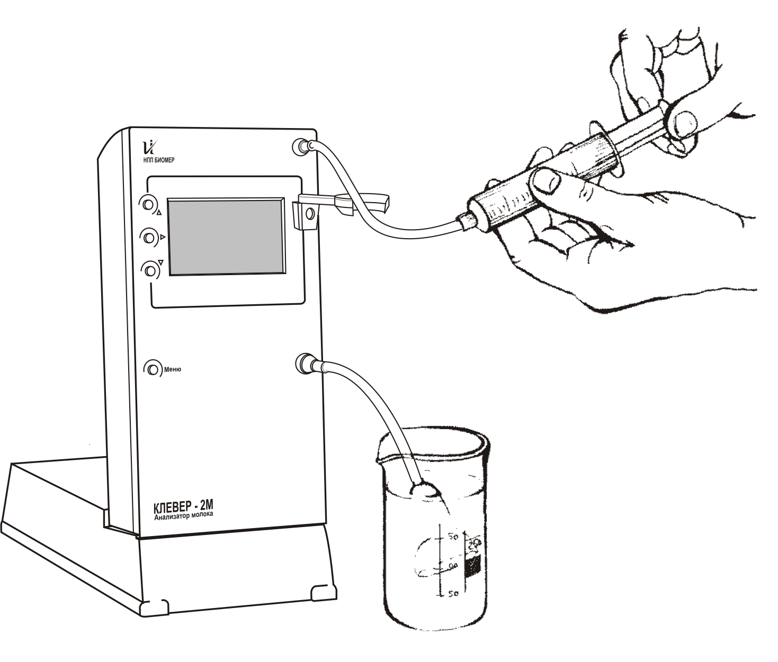
Fig. 9 Washing the Analyzer

Prior to starting any measurements (after washing), wash the cell with distilled water 2 or 3 times.

4.3 Monthly Washing the Analyzer

With regular daily washing, no monthly washing is needed.

Whenever a monthly washing of the analyzer is needed for some reason, perform the following steps:
- pour the hot working “Alubrake-Extra” solution (about +60ºC) into the cell and leave it for 1 hour. Then drain the solution and wash the cell with warm water.
Check it for any visible particles or sediments—repeat the procedure until they vanish completely.

Then perform the steps of 4.2 (1-4) from the Daily Washing section of this Manual.

On finishing the monthly washing of the analyzer, do perform its operability check as per the guidelines of Section 4.4. in this Manual.
For more detailed recommendations on maintenance of the analyzer, see the washing instructions.

Note that washing of analyzers with regular synthetic detergents has a few shortcomings; in particular, most of these detergents contain structured, poorly soluble particles which may sediment on the interior surface of the measuring cell and silicon pipes. We don’t recommend using household detergents and dish-washing solutions.

Ensure the analyzer is washed:
- daily at the end of the working day;
- prior to measurements after prolonged storage;
- prior to zero adjustment of the analyzer.

OOO NPP Biomer guarantees stability of readings and operation of the analyzer only if special washing solutions are regularly used. Washing kits can be purchased at the manufacturing plant.

4.4 Operability Check of the Analyzer

The operability check of the analyzer implies validation of the readings produced from measurements conducted using distilled water. The control of deviations of the analyzer should be carried out daily prior to the works as well as in some questionable cases. To this end, run two preliminary measurements in Mode 1 using distilled water followed by a check measurement with distilled water.

The check result can be regarded satisfactory provided the following conditions hold:
- the measured value of fat mass content in the distilled water is within ±0,03%;
- the measured value of NMS mass content in the distilled water is within ±0,03%.

In case of mismatch between the readings on the device and the above values, the analyzer needs maintenance.

If after the maintenance the measurement results do not match those specified, the analyzer needs a manual zero adjustment.

To check the operability and control of precision of the factory-set calibration, we recommend using special “imitating mixes” produced by OOO NPP Biomer. In using the mixes, perform the same procedures as those performed with distilled water as well. The value of the indicator being checked and its maximum error are stated on the package of the imitating mixes. See also Section 8.8.

4.5 Troubleshooting

In case of an operational fault with the analyzer not given in Table 4, never try to eliminate it on your own but contact the manufacturer.

Table 2
Type of Fault | Causes | Troubleshooting Methods
1. The analyzer is plugged in to the mains, but it won’t start when the power button is pressed. | Poor contact with the mains plug.  Power cable cut off.  Power source is faulty. | Ensure the mains plug is operative.  Replace the power cable.  To be carried out by the manufacturing plant only.
2. Sample receptacle tube is faulty. | Ageing, heavy clogging or damage of the hose. | Replace the faulty hose with a backup hose available in the delivery set.
3. Characters not matching any of the modes described in the Operation Manual are displayed. | Erroneous or accidental load of a setup mode of the device. | Power the analyzer off the mains and power on again in 10 seconds.
4. The analyzer operation does not comply with this Operation Manual. The analyzer does not display results, operational faults accompanied by warnings, the measurement error is well over the admissible values and can’t be eliminated through zero adjustment, etc. | One of more circuit components of the device is faulty. | Replace the faulty circuit component.  To be carried out at the manufacturing plant or by its authorized representative in your region.
5. The error message “Overheating add and drain off the sample” is displayed. | Cell overheated after the zero adjustment. Other possible causes—high temperature (over +35 ^{о}С) of the sample or air in the premises. | Pour and drain the sample. Eliminate the cause of overheating.
6. The error message “internal error” or the “!!” icon is displayed. | Incorrect value of the cell parameters. | Perform the maintenance and operability check of the analyzer. If the error indication persists, contact the manufacturing plant for assistance.

5. STORAGE

Store the analyzer in dry heated premises at temperatures from +5 to +30°С and relative humidity from 30 to 80%.

Do not expose the analyzer to direct sunlight. The air in the premises must be free from dust and mixtures of aggressive vapours and gases.

Avoid sudden impacts and shocks upon the analyzer.
Do not store the analyzer near heating radiators and other heating systems, as well as in premises of high humidity and frequent temperature fluctuations.

On sharp temperature fluctuations (while moving the analyzer between premises), put the analyzer in a plastic package.
Keep the analyzer in shipping container indoors as per the requirements of group 5 in GOST 15150.

Prior to putting the analyzer into operation after transportation and storage in a shipping container, keep the analyzer in the respective operating conditions for no less than 2 hours.

6. TRANSPORTATION

The analyzer must be transported in a packaged form, in a covered vehicle in compliance with the cargo transportation rules acting for the given type of transport. Transportation conditions as per group 5 of GOST 15150.

Never transport the analyzer in a vehicle used to conveying active chemicals as well as in vehicles contaminated by dust of coal, bricks, and cement.

Transportation should be performed under temperatures from – 50 to +50°С, relative air humidity up to 95% and at 25°С.
The layout and fastening of transportation boxes should guarantee their firm position en route and no collisions. Transport the device under jolting acceleration no more than 30 m/s² and at frequencies of impacts not exceeding 120 strokes a minute.

Keep the factory container safe during the whole operation life of the analyzer to prevent its damage in case of transportation to a repair or verification utility.

7. RECYCLING

The analyzer does not contain precious metals or substances hazardous to the environment and should be recycled in a regular manner.

8. ADDENDA

8.1 Control options for Mode 2

Running measurements in Mode 2 is a relatively complex and labour-intensive process, especially if the user lacks adequate skills of handling chemicals and equipment. In cases like these, the Klever-2M analyzer provides control options which allow keeping track of the right preparation and measurement of the sample based on the interior characteristics.

The pouring control does not allow to change the sequence of pouring milk and whey. This control option also keeps track of the sample optimum parameters so that in case the parameters (e.g. turbidness or temperature of the sample) are much higher or lower than the optimum, then the option of pouring control “snaps on”, therefore the analyzer displays the message “drain off the sample”. In this case, the parameters of the sample should be either brought to the optimum values or re-analyzed, or the pouring control option should be disabled.

The whey control keeps track if the whey is prepared adequately and at the same time ensures the right selection of object for analysis. In case a wrong object for analysis is selected and it does not meet the measuring ranges of Mode 2, or if the whey was prepared inadequately, the whey control option may “snap on”. In that case, the analyzer displays the message “incorrect sample”.
Stability control allows to avoid accidental measurement errors. In so doing, the analyzer prompts to pour the sample (whey or milk) as many times as the measurement stability control option “snaps on”. Therefore, the measurement of whey and milk is performed at least two times, which allows to obtain the most reliable result.

The analyzer also offers a permanent interior check of the sample (which cannot be disabled). Once this control option “snaps on”, the analyzer displays the cause (e.g., “De-aerate sample”) or indicates “incorrect sample” message and prompts to confirm output of the results to the screen. For such a sample, the measurement result may go outside the metrological specifications of the analyzer.

8.2 Use of Сorrection of Mode 1

Note that for Mode 1 the analyzer is calibrated using undesignated cow milk, and the used estimation coefficients relate to the average values for cow breeds and regions of the Russian Federation.

Therefore, if you run an analysis of milk or a separation product obtained from an individual trader or using a technology that modifies the physical and chemical properties of the milk product (e.g. homogenization), then you may come across the result going outside the limits of the analyzer metrological specifications.

To eliminate the possible effect of these factors, the Klever-2M analyzer provides operation in Mode 2 for correction of Mode 1, which allows “tuning” Mode 1 for the composition specifics of the milk being analyzed and thus gives a higher precision of further measurements of the milk.

For example, on change of forage in a certain milk herd, the lactose contents went up considerably above the average, and the lactose defined in Mode 1 is statistically understated by 0.1%. In this case, correction will eliminate the specified understatement, and in further measurements run in Mode 1 the determined value for lactose will be expressed in terms of the correction.

In the correction mode, all the control options (see Section 8.1) of the analyzer are enabled, therefore, if the user misprepared a whey or attempted to run a correction using a sample of milk other than cow milk, this action will be denied.

If, while making a correction the user comes across errors in preparing samples, the Resetting Correction allows restoring the calibration default settings of the analyzer.

Correction of Mode 1 is provided only for whole raw and reprocessed milk. Therefore, you should not run a correction at some other object, which may entail deliberately wrong results.

8.3 Determination of Added Water in Milk

The analyzer offers the option of determining the quantity of water added into milk. The mass fraction of added water can be determined within the range from 3 to 70 %. This indicator is determined in raw milk of fat content ranging from 1.5 to 5.5%.

The threshold NMS value is used to calculate the quantity of water added into milk, that is, if the measured NMS value is less than the threshold, it is regarded that milk is diluted with water. The threshold NMS value is set to 8.2 at the factory. Prior to operating the analyzer, it is recommended to set a NMS value currently minimum for your region, and then correct it periodically on seasonal change of feeding conditions and conditions of maintaining the milk herd.

8.4 Purpose of Calibrations and Modes of the Analyzer

It should be noted that the most accurate and correct readings of the product being analyzed will be attained only if a calibration specially designed for a particular product is used. In its standard delivery set, the analyzer is equipped with three aligned calibrations for full cow milk and products of its separation—skim milk and cream of fat content ranging from 0 to 20%. (Calib. 1 BIOMER). This calibration is used in Mode 1. The calibration is also adapted for analysis of “reprocessed” full milk, that is, milk that has undergone normalization, homogenization, pasteurization, or sterilization. Therefore, this calibration is also applicable for milk in the form of a ready product within the 1.5-5.5% interval of fat content.

Currently, BIOMER can offer two additional calibrations for ice-cream and reconstituted milk. The metrological specifications for analysis of the mentioned products are listed in a separate Measurement Technique (MT) which is provided on ordering a respective calibration. Calibrations are performed at extra charge. For details of the timelines, prices, and options for calibration feasibility to order for an individual product of the customer, call to the company’s office or place your request at the company’s web site.

Mode 2 of the analyzer is designed to analyze full cow milk, both undesignated and the milk from an individual animal. With Mode 2 the user can correct Mode 1 to produce more accurate results, as is described in Section 8.3.

To allow the user to analyze undesignated milk and milk which characteristics and composition are sharply different from those of undesignated milk during acceptance of produce (e.g., goat milk), the analyzer in its base delivery set is equipped with a special calibration (Calib. 2 User). This calibration is not enabled at the factory and is not meant for analysis. To enable it, set the «User» calibration, run a correction of Mode 1 of this calibration as is described in the respective section of this Manual, and upon confirmation of successful correction set the indication of readings required for analysis carrying-out.

We also recommend using a user calibration while getting familiar with the operation of the analyzer and running “trial” modifications to the settings.

If necessary, several user calibrations can be written to the analyzer.

8.5 Milk Homogenization Rate

The Klever-2M analyzer offers the option of determining the milk homogenisation rate. The homogenization rate is an engineering parameter used in reprocessing milk and has no metrological specifications. Homogenization rate is indicated for the reprocessed milk only. In other cases, the analyzer indicates “No” pointing to the fact that homogenization calculation is not possible for this measurement.

The homogenization rate is in direct dependence on the internal characteristics of the device, therefore, to produce the most accurate results it is necessary to perform periodic maintenance and, in particular, the “zero adjustment” of the analyzer.

8.6 Milk Freezing Point

The Klever-2M analyzer offers the option of determining the freezing point of raw milk. The freezing point is determined by the analyzer based on the measured values of milk composition. The metrological specifications for this indicator are stored only while running analysis in Mode 2. The freezing point is a physiological constant which is specific for each region and breed of milk herd. The manufacturer set the freezing point average for regions of the Russian Federation, however, if the user decides to correct the freezing point in accord with its average value for a given milk herd, so the following has to be done:
1. Select an averaged (combined) sample of milk which is characteristic for the given region and the milk herd.
2. Determine the freezing point for the sample using any direct method (e.g. cryoscopic).
3. Using the “Menu” (User F.point), modify the indicated value (for which measure the averaged sample) for the freezing point determined by the direct method. Confirm the changes.

Then, while measuring the freezing point, the analyzer will take account of the value entered by the user.

8.7 Measuring Cream of Fat Content Over 20%

If the user needs to measure the indicators of a milk product (cream) of fat content over 20%, then such a measurement should be effected through dilution of cream in order to reduce the fat content to the limits specified by the range of metrological specifications.

To make the dilution procedure as simple as possible and adapt it to the capabilities of Klever-2M analyzer, we recommend to keep to the following guidelines:

- It is advisable that distilled water be used to dilute a sample.
- In lack of distilled water, use boiled water with the maximum lowest salts content.
- Sample must be degasified.
- Share of product dilution must be minimum, that is, if you need to analyze cream of approximate fat content 35%, then it suffices to dilute it twice to the fat content 15-20%.
- It is advisable to run several measurements and average the produced values for fat and protein.
- If you determine the composition of a final product of reprocessing, then it is already most likely degasified, pasteurized and homogenized. Depending on that, it is advisable that a special calibration be used. You should also note that milk homogenization results in the change of metrological specifications of the device, because the upper boundary of the range for fat measurement will be reduced by almost two times to 8-12%. For instance, if while measuring a homogenized product diluted to 10% fat content the device displays the message “internal error drain off the sample”, dilute the product more by 10-15%.
- It is not recommended to dilute the product to a fat content below 5.5% because in that case the device may apply a scheme of parameter calculation to the product but that scheme is not meant for cream (see also Section 8.4).
- Value of density indicated by the device while analyzing a diluted product is not correct and its use is not recommended.

8.8 Certified Mixtures for Verifications

The analyzer is verified in compliance with the methodology INK 250.000.006 IZ approved by FGUP UNIIM. The verification methodology defines two options it should be run. According to the first option, the analyzer is verified as a universal device where the value of the output signal is controlled (which is equated to the readings for fat), its instability and the root-mean-square deviation. The second option (verification using the MT) implies that during verification all the metrological specifications and correctness of the readings can be checked against the factory calibration.

The verification is performed using attested mixes prepared as per the guidelines attached to the analyzer.
Depending on the analyzer verification option selected, our enterprise could offer certified mixtures and standard samples for both control over the output signal and for control over all the declared metrological specifications of the analyzer. For details of the certified samples, contact the sales office of OOO NPP BIOMER or check the company’s web site.

All the measurements of certified mixtures produced by the company are to be run in Mode 1 with Calibration 1 “Biomer”. If the factory calibration was corrected, perform the Resetting Correction action in the respective “Menu” section of the device.

8.9 Possible Discrepancies in the Readings

8.9.1 Discrepancies Related to the Analyzer Faults

In case of substantial discrepancies in readings of the analyzer and data on the composition of the sample produced by some other method (including a similar analyzer), we recommend to thoroughly analyze the situation and perform the operations as follows:
- Ensure that all the recommendations of this manual in the part of technical maintenance, correctness of object selection, sample preparation, modes and settings have been followed correctly and in full.
- The discrepancy should be significant and statistically justified. That is, the discrepancy should be greater than the total errors of the analyzer itself and the controlling methodology. Measurements should be conducted with several objects in repeatable and reproducible conditions.
- Set the absolute value of discrepancy.
- If there is a sample of certified composition, run a measurement using the sample. Note that this sample should comply with the calibration used.
- If possible, read the inner settings from the device memory using the special program Конфигуратор.exe (3.8.4 Software Setup) which is written on a disk shipped with the analyzer. The program is also available to download from the company’s web site.
- Activate all the data obtained as per items 1-5 and contact the manufacturing plant with a respective request made up in an arbitrary form. It is also advisable to submit a file of data obtained as per item 5.

8.9.2 Discrepancies Related to Errors of the Controlling Methodology

The chemical analysis of a sample is an important part of activities at any laboratory no matter if the analysis is used to calibrate instrumentation or to monitor its operation. With all the seeming simplicity of the methods used (e.g. determination of fat content as per Gerber’s technique), there is a substantial amount of fine points which are not paid sufficient attention, but it’s just these fine points which may introduce considerable systematic errors into the analysis.

It quite often happens that a discrepancy between the readings of the milk analyzer and the results obtained based on the data of chemical analysis is caused by just because the controlling method of analysis was not performed correctly.

The errors of the methods and possible systematic errors that arise during their implementation have been extensively reported in the literature. Some errors, as well as ways of their elimination, are described at the web site of OOO NPP BIOMER in the Library section. You may contact the laboratory of OOO NPP BIOMER for consultancy on any topic of interest in the part of performing a chemical analysis.

8.9.3 Discrepancies Related to the Specifics of a Region and Feeding of the Milk Herd

As was already mentioned, the properties of raw milk are subject to a substantial effect depending on a number of factors. The sharper changes occur to a factor, the more pronounced the change of properties will be. The factory-set calibration written to the analyzer was performed as applied to undesignated milk and takes account of all the seasonal changes of milk properties. However, a sharp change in these properties, e.g. on transition from winter to summer forage may dramatically change the composition of milk. Moreover, the relative contents of milk components may go outside the natural limits. In this case, the readings of the analyzer may be higher than those in the metrological specifications. Similar situation will be observed for milk from an individual animal, sick animals, or animals at an early of the last stage of lactation. To take account of these changes, it is recommended to run correction of Mode 1 (see 8.2). If correction is no longer needed, e.g. after elimination of a factor that changes the milk composition, then either perform “Resetting correction” or restore the factory default settings, or repeat “Correction of Mode 1” by tuning the analyzer for milk of the available composition.

For consultations on any matters of interest, call the office of OOO NPP BIOMER at (383) 308-75-00 or place your request in the Guest Book at the company’s web site www.biomer.ru, or send a letter to info@biomer.ru.

NOTES

* - Non-normalized metrological indicators.

